|  |  |
| --- | --- |
| **Name:- Aryan Dilipbhai Langhanoja** | **Roll Number:- 92200133030** |
| **Subject Name and Code:-** Foundation Skills On Sensor Interfacing (01CT1103) | **Date of Experiment:- 17-12-2022** |

|  |  |
| --- | --- |
| Task:- |  |

Interface Ultrasonic with arduino and show the results on serial monitor.

|  |  |
| --- | --- |
| Components: |  |

* Arduino Uno R3
* LED
* Ultras0nic Sensor HC-SRO4
* Jumper Wires (Male To Male)
* Bread Board
* Laptop Or PC

|  |  |
| --- | --- |
| About the Project:- |  |

* In thisproject, we are going to Interface Ultrasonic Sensor HC-SR04 with Arduino. Ultrasonic pin has four pins in it. One is VCC which is connected with +5V of the Arduino Uno. And there are trigger pin and echo pin which are connected to digital pin 12 and 13 respectively. And one pin left which is ground and it is connected with the GND pin of the Arduino.
* The HC-SR04 Ultrasonic Distance Sensor is **a sensor used for detecting the distance to an object using sonar**. It's ideal for any robotics projects your have which require you to avoid objects, by detecting how close they are you can steer away from them!

|  |  |
| --- | --- |
| Output (you circuit implementation):- |  |

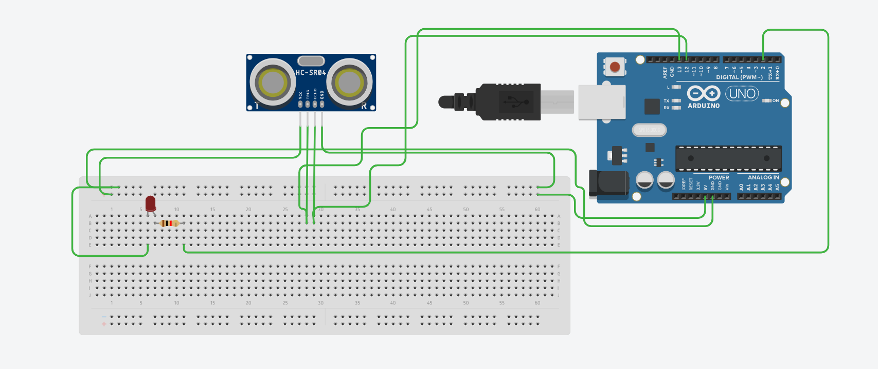

|  |  |  |  |
| --- | --- | --- | --- |
| Schematic:- |  |  |  |

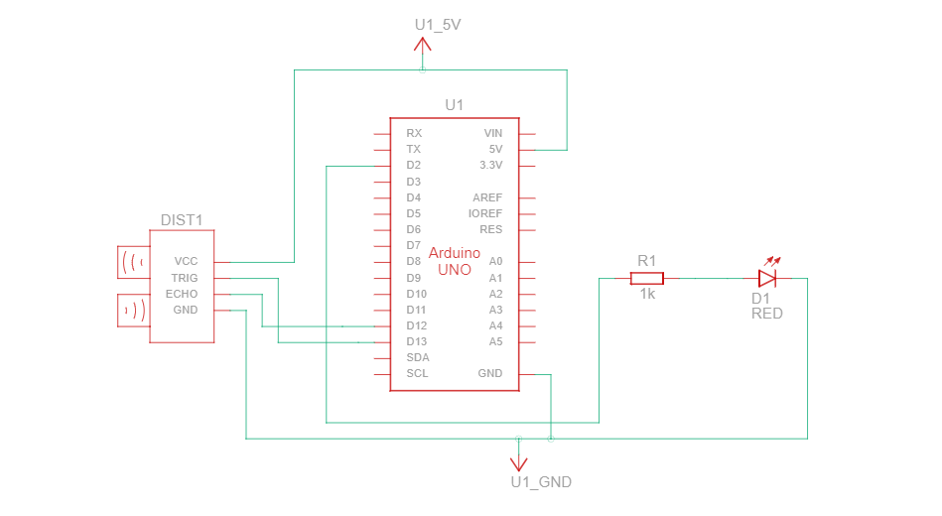

|  |  |
| --- | --- |
| Application:- |  |

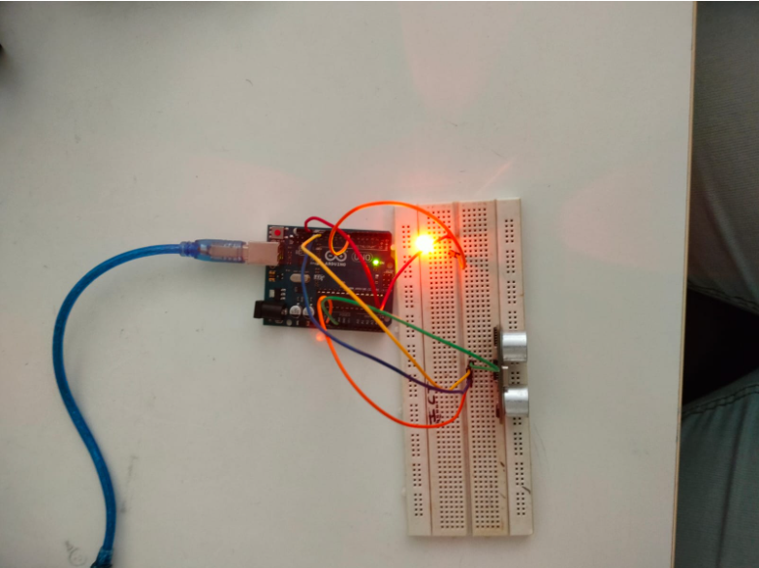

|  |  |
| --- | --- |
| Code:- |  |

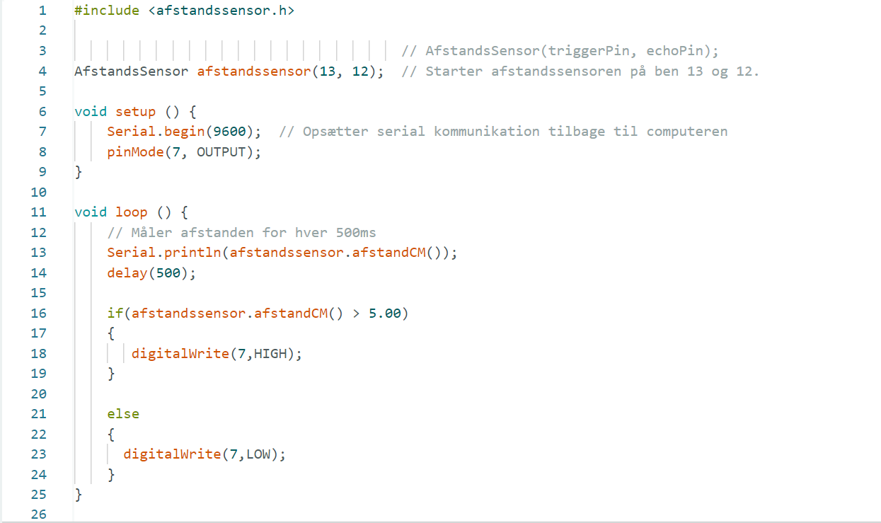

|  |  |
| --- | --- |
| Result Of Serial Monitor :- |  |

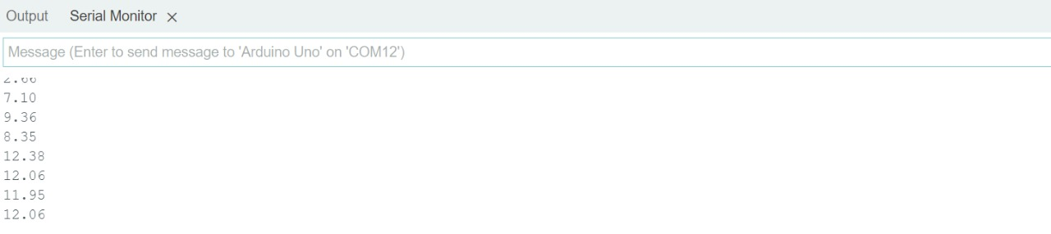

|  |  |
| --- | --- |
| Conclusion:- |  |

* In This Experiment, We Learnt How To interface Ultrasonic sensor With Arduino. And how to measure Distance from that.